Assignment 2

By Nizar Van Hool

Cloud project

url: <https://carmetrics.xyz/>

IP address: 13.201.153.54

**Table of content**

1. **Setting up webserver**
2. **Connecting to Apache 2**
3. **Connect Instance to DNS**
4. **Setting up SSL certificate on ubuntu**
5. **Setting up GitHub and pushing.**

**Setting up webserver:**

1. You need to launch a ubuntu and associate Elastic IP address

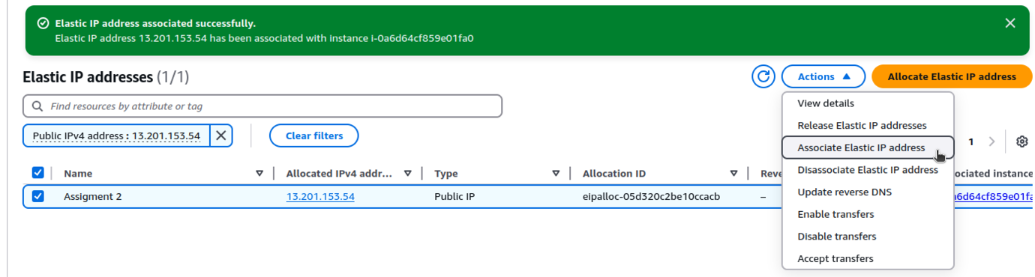

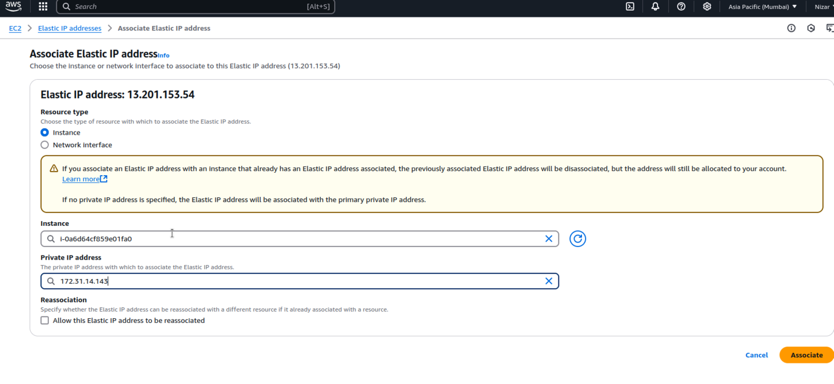

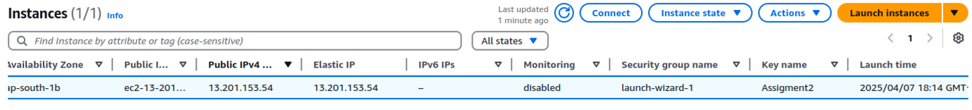

1. Connecting EC2 instance to ubuntu:

**Connecting to Apache 2**

Do be able to have you website running on html code in your instance you need to install apache 2 which is a server software.

1. You need to make sure everything is updated



1. Now we will install Apache2



1. Now we will need to enable Apache to start on boot



1. Verify that Apache2 is running

Now Apache2 should be running on

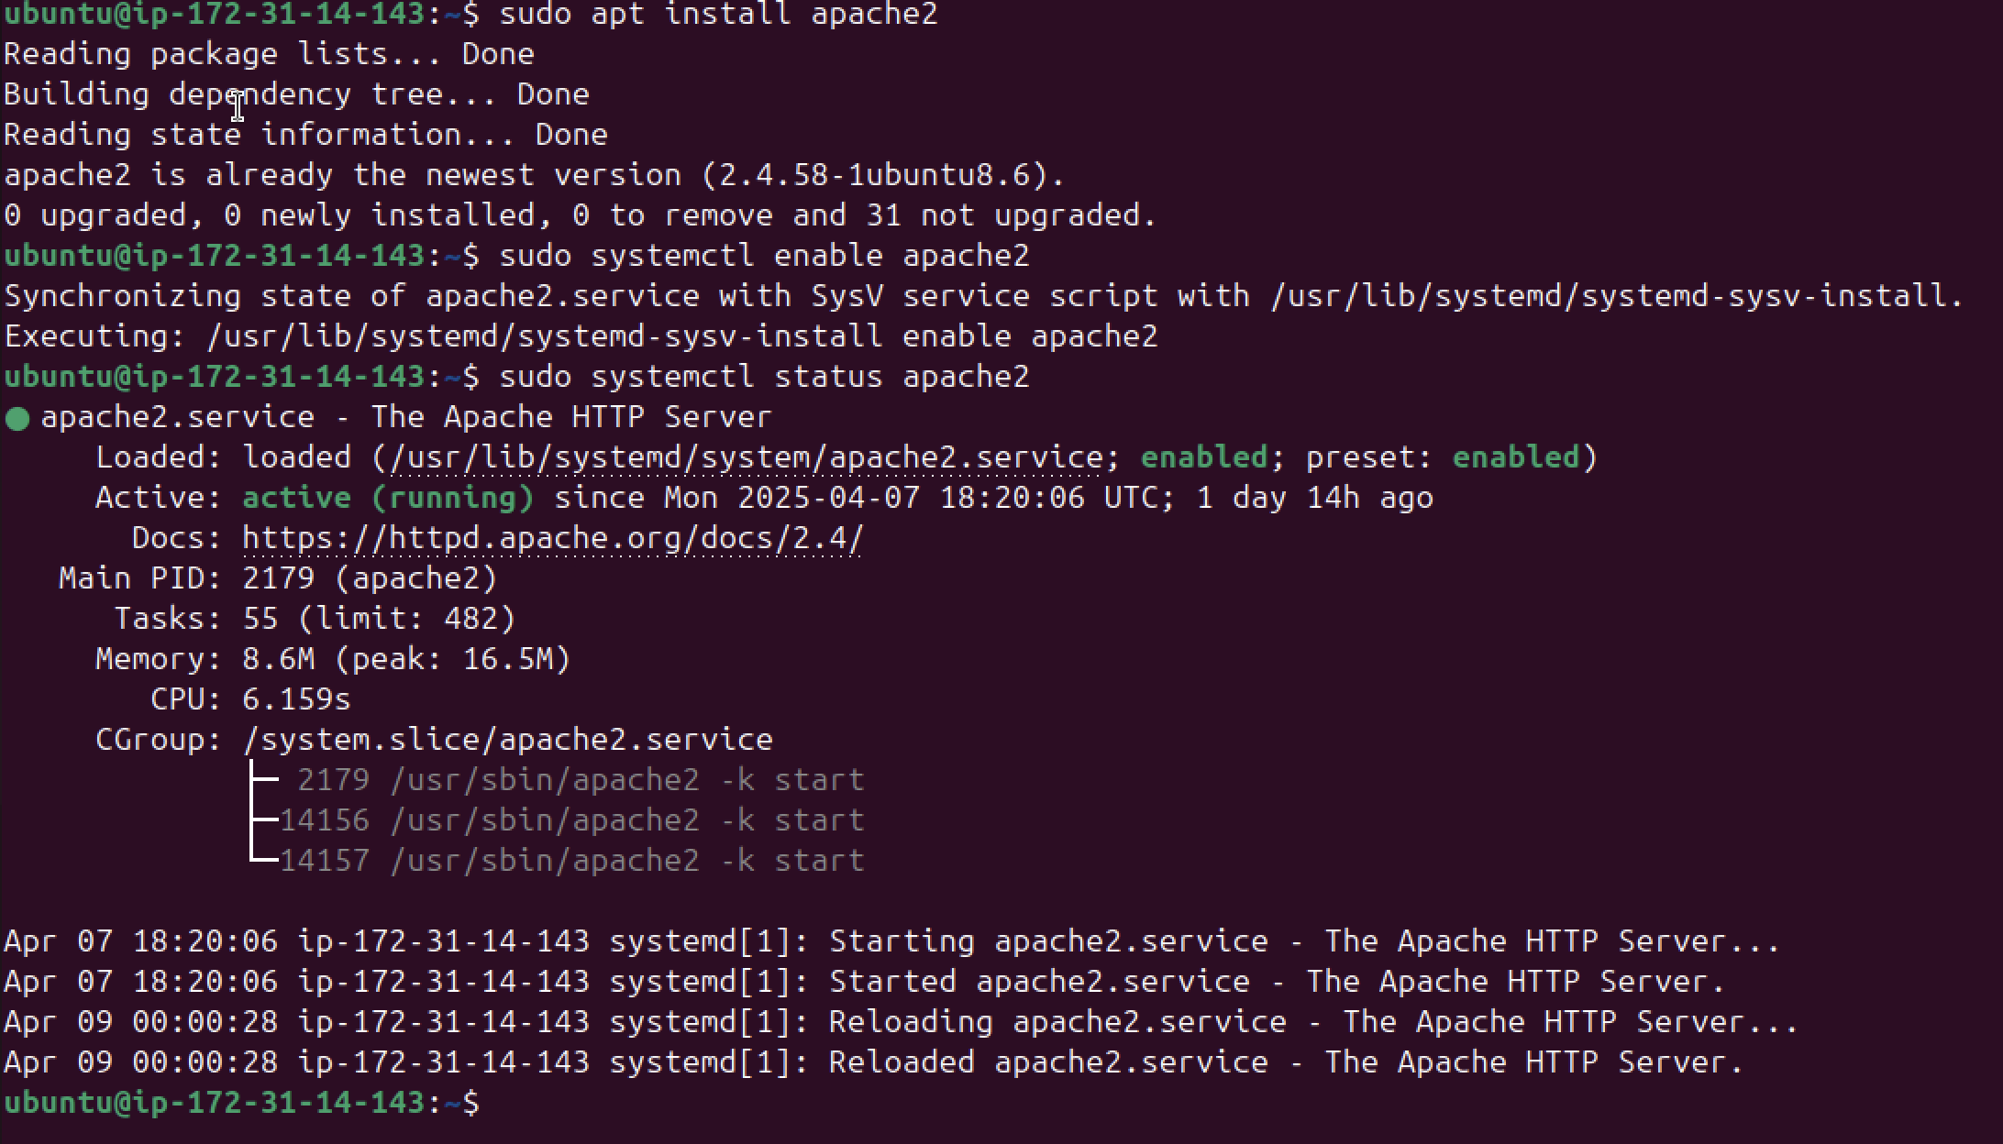

Done successfully it is running

**Connect Instance to DNS**

1. Create a route 53 account

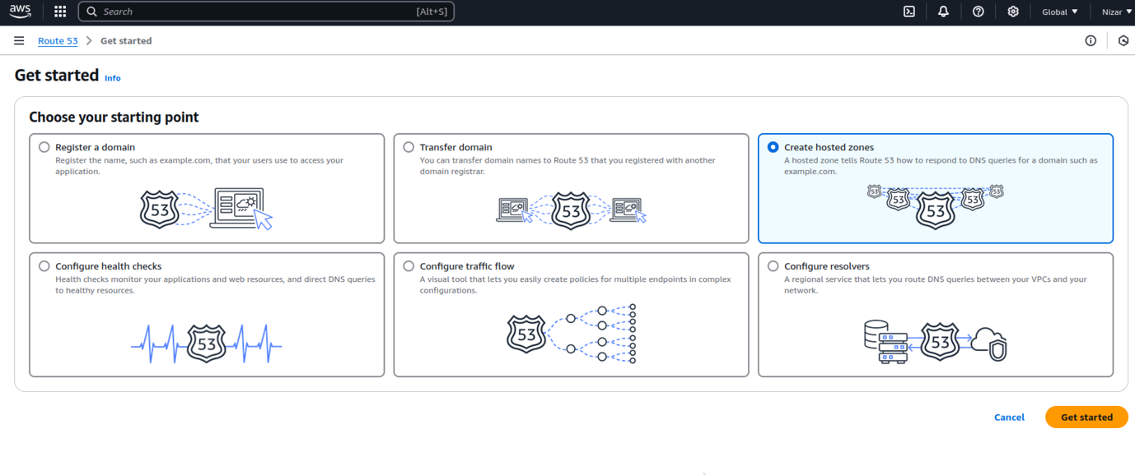

1. Create a hosted zone enter domain name and select public hosted zone

Enter domain name and select public hosted zone then create.

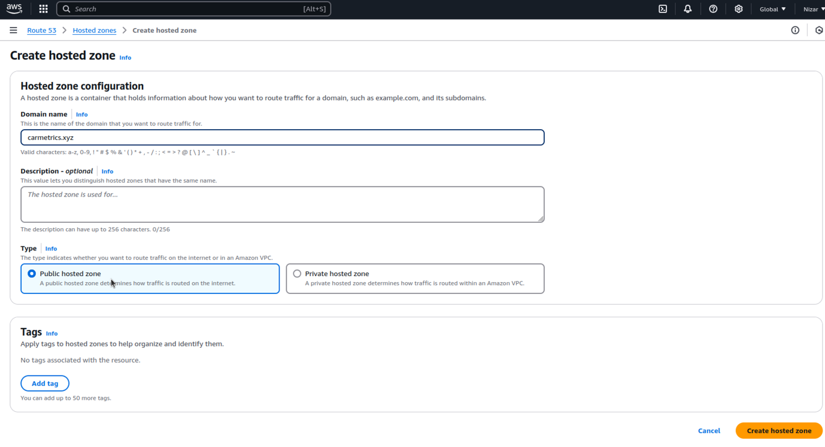

1. Create a A record which will map domain name to IP address

Enter IP address in value and create

1. Create CNAME record to map domain name

Enter www in record name and enter domain name in value and create record.

1. Connect ur domain name to instance

Copy and past all values and past in GoDaddy nameservers

**Setting up SSL certificate on ubuntu**

1. Installing the required packages



1. Install Cerbot with Apache plugin

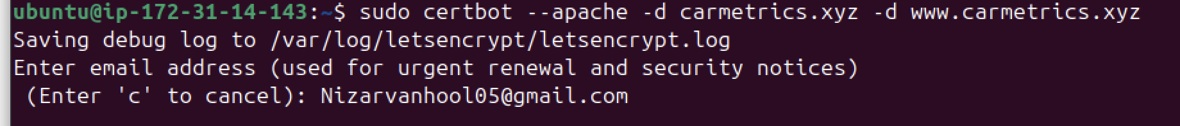

**Making MIT License**

1. **Open Website root folder**



1. **Create new file called License**



1. **Enter license inside of file**

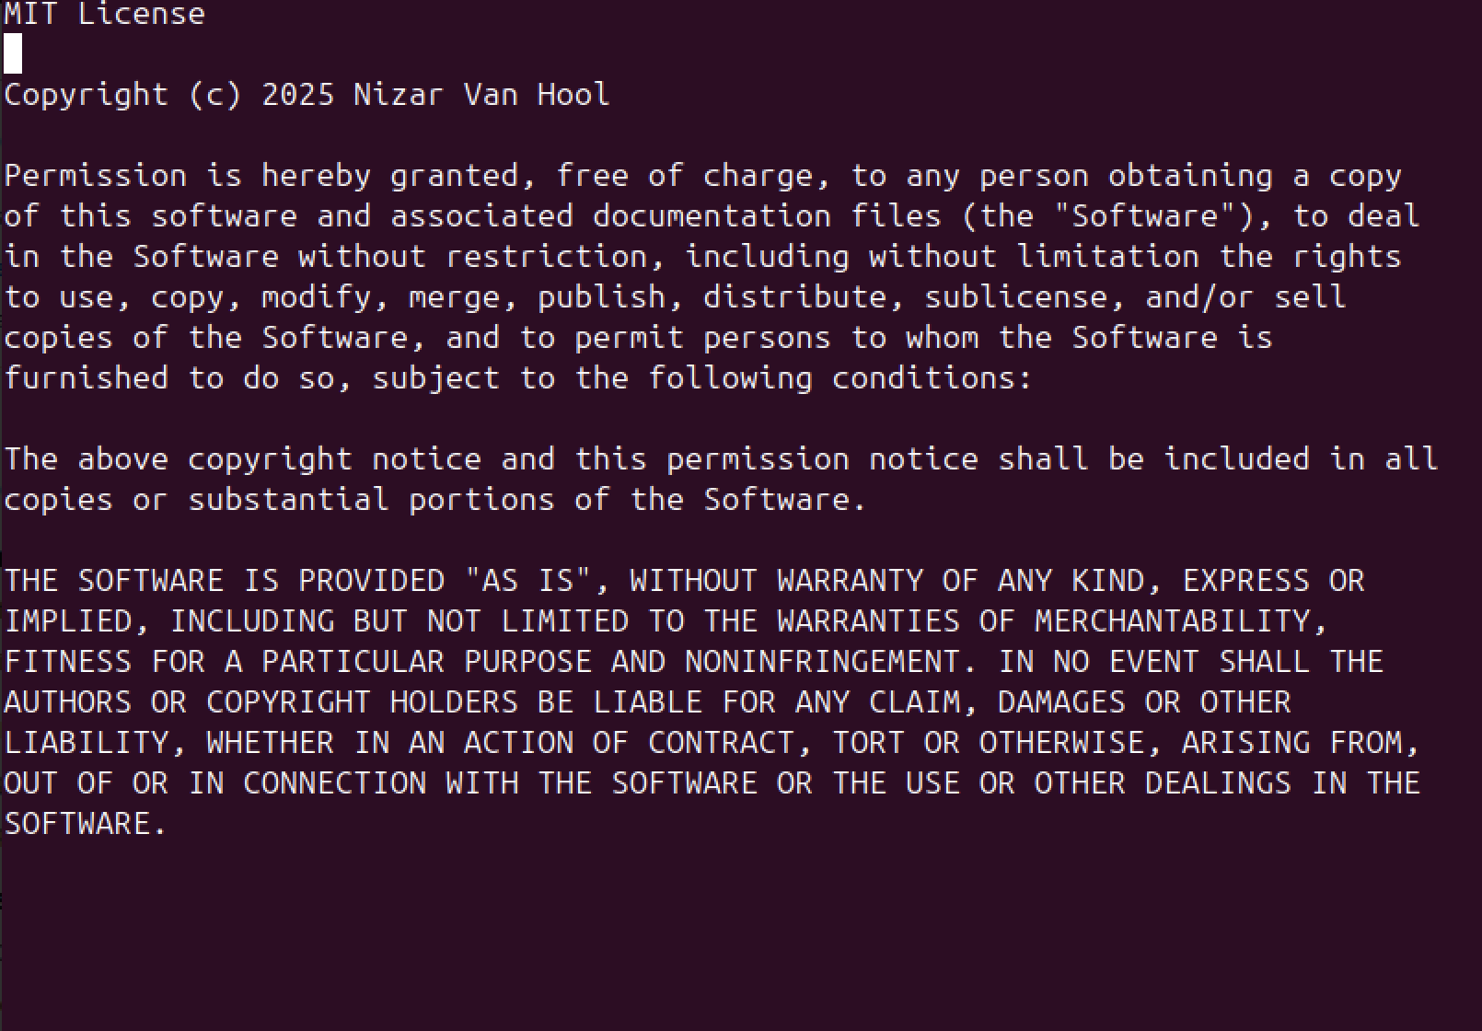

**Setting up GitHub and pushing.**

1. **Install github on terminal**



1. **Set up git**



1. **Initialize Git**



1. **Add and commit files**



1. **Connect to Github**



1. **Push to GitHub**

